

School of Science, Engineering and Technology

**Engineering Design 2**

EEET-2602: Session 1 – Team 1

**Assessment 4**

**Submitted by**

Student #1: Truong Tan Gia Huy - s3806881

Student #2: Nguyen Bao Tuan - s3713061

Student #3: Do Manh Huy Hoang - s3819663

Student #4: Duong Hai Nam - s3836626

Authors Statement: This lab is the original work of the above authors. We as authors understand that resubmissions of others' work without proper citation is an act of plagiarism and is subject to the penalties as put forth by RMIT University Vietnam and the School of Science, Engineering and Technology.

Date Submitted: 20th September 2022

Lab Session: 1

Course Instructor: Mr. Khuong Nguyen

**Table of Contents**

List of Figures ........................................................................................….…............................. 2

List of Tables ..................................................................................................……...................... 2

Nomenclature ............................................................................................................……........... 2

Introduction.......................................................................................................................…….... 3

Circuit Design and Simulation.....................................................................................……......... 3

PCB Design…………….............................................................................................…….......... 6

PCB Manufacturing and Soldering Process............................................................................….. 7

Circuit Test…………................................................................................................................... 12

References .......................................................................................................................…….... 14

**List of Figures**

Figure 1 –………………………….……...…………………………………………………… 3

Figure 2 – …………………………………………………………………..……………...….. 4

Figure 3 – ……………………………………………………………………………………... 5

Figure 4 –………………………………………….………………………..……………...….. 5

Figure 5 – ……………………………………………………………………………………... 7

Figure 6 – ……………............................................................................................................... 7

Figure 7 – ……………............................................................................................................... 9

Figure 8 – ……………............................................................................................................... 9

Figure 9 – ……………............................................................................................................... 10

Figure 10 – ……………............................................................................................................... 10

Figure 11 – ……………............................................................................................................... 11

Figure 12 – ……………............................................................................................................... 11

Figure 13 – ……………............................................................................................................... 11

Figure 14 – ……………............................................................................................................... 12

Figure 15 – ……………............................................................................................................... 12

Figure 16 – ……………............................................................................................................... 13

**List of Tables**

Table 1 – ……………………………………..……………………........................................... 3

Table 2 – ……………………………………..……………………........................................... 6

Table 3 – ……………………………………..……………………........................................... 13

**Nomenclature**

IC = Integrated Circuit

PCB = Printed Circuit Board

$V_{RMS}$ = Root-mean-square Voltage

$P_{Loss}$ = Power Loss

**Introduction**

In this Group Design Project Report on Final Circuits, students are expected to work in a group of four to design a Switch Voltage Regulator Circuit on a PCB. In order to achieve the requirements, students need not only the familiarity with the PCB design process, the understanding of circuit design process, a good PCB soldering standards and the circuit design applications in the industry but also be able to test the circuit performance after getting the PCB ready.

**Circuit Design and Simulation**

In this section, students will need to do the simulation of the circuit in Figure 1.

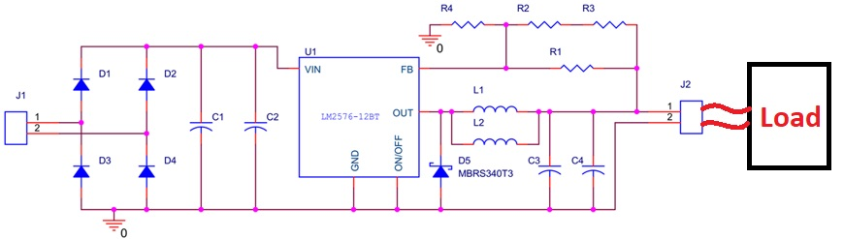

*Figure 1. Real circuit to be simulated and tested*

Detailed component values and models are shown in Table 1.

Table 1. Components’ values and models

|  |  |  |
| --- | --- | --- |
| Device | Model | Name on Schematic |
| Diode (normal) | 1N4001 | D1, D2, D3, D4 |
| Diode (Schottky) | MBRS340T3 | D5 |
| Linear Regulator IC | LM2576 | U1 |
| Inductor | 220uH | L1, L2 |
| Capacitor | 330uF | C1, C2, C3, C4 |
| Resistor | 8.2kΩ | R3 |
| Resistor | 1.3kΩ | R4 |
| Resistor | 2.4kΩ | R1, R2 |

In this circuit, a design of a Voltage Regulator using an IC Linear Regulator was considered. Prior to having the actual circuit board designed, the simulation process should be taken by the team members. NI Multisim 14.2 is the tool that will be used in this simulation process. The IC chip in the real circuit is LM2576 model while this model is not available in NI Multisim. The team proactively used LM2592HVS-ADJ/NOPB, which its characteristic can be sufficiently compared to the LM2576 one. The input of the experiment is 5 $V_{RMS}$ which will be taken directly from the NI Elvis II board and to be tested at 100kHz. The reason for testing the circuit of a circuit with an IC Linear Regulator at 100kHz is because this model is a high frequency switch regulator (150kHz Fixed Frequency Internal Oscillator) and this higher internal frequency allows the use of a smaller inductor and capacitor [1]. Also, at 100kHZ frequency range, the noise is integrated and gives accurate representation of the noise performance [2]. The load is simulated at 330 Ohms.

The simulation process was run with the simulation circuit in NI Multisim as shown in Figure 2.

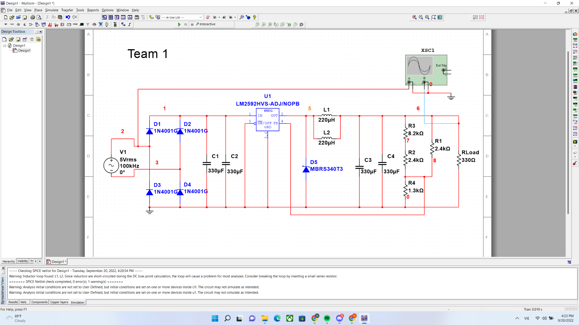

*Figure 2. Simulation circuit on Multisim*

The simulated results are shown in Figure 3.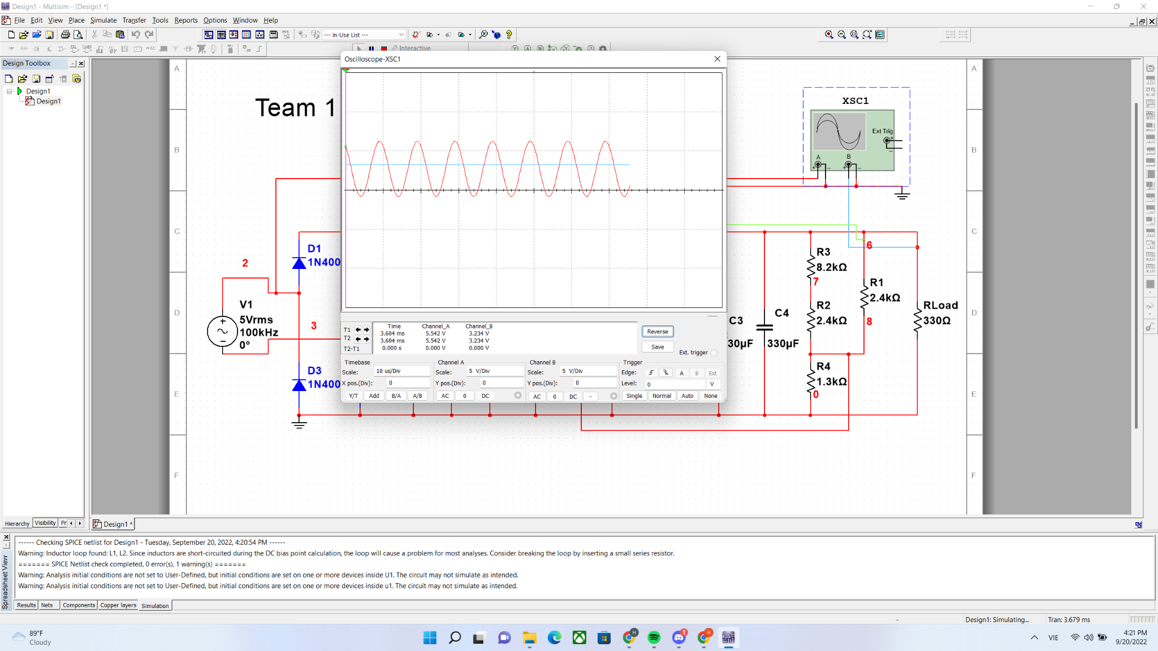

*Figure 3. Simulation results on Multisim*

The simulated results are analyzed by using the cursors as shown in Figure 4.

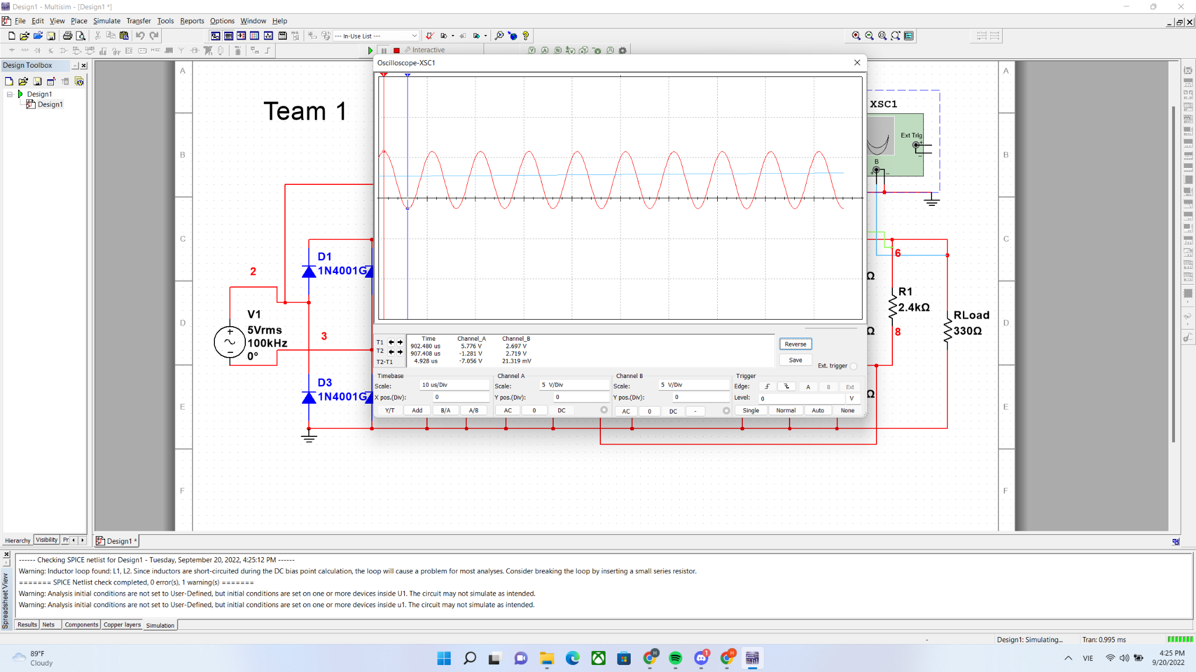

*Figure 4. Simulation results analysis with cursors on Multisim*

In the design, two inductors were connected parallel to reduce the current and minimize the power loss and voltage drop during transmission ( $P_{Loss}$ = I²R) [3]. The total inductance of two parallel inductors will be less than any inductance of the two inductors [4]. Capacitors C1 and C2 were used to store energy then release energy when the MOSFET in OFF state to prevent input voltage drop to the IC Linear Regulator while capacitors C3 and C4 were used to store energy then release energy when the MOSFET in OFF state to reduce the IC Linear Regulator output voltage drop to the load [5]. Schottky Diode was placed at the output of the IC chip to lower forward voltage drop and result in less heat being generated. Schottky Diode is very quick at switching between rectifying and non-rectifying states when the frequency of the input sine wave is high [6].

From the information that was found through the cursors in Figure 4, the team came up with the data of simulation in Table 2.

*Table 2. Simulation Data Summary*

|  |  |  |
| --- | --- | --- |
| Data name | Value | Unit |
| Output voltage | 3.085 | V |
| Ripple voltage | 0.048 | V |
| Output current | 0.009 | A |

$$Output current=\frac{Output voltage}{Load}=\frac{3.085}{330}=0.009A$$

To measure the Ripple voltage, we will use the oscilloscope. For channel A is connected to output of the 4 diodes and channel B is connected to output of the 4 resistors. Then we will take the highest value minus the lowest value which is 3.131-3.083 = 0.048V. The reason why the ripple voltage is so low and nearly 0 is because the capacitor is so big which means that when the capacitors haven’t fully discharged yet, it’s already pumping electricity into the capacitors.

**PCB Design**

After simulating the circuit, the team started to design the PCB and have its schematic designed the same to Figure 1. Detailed components’ footprints are in Figure 5.

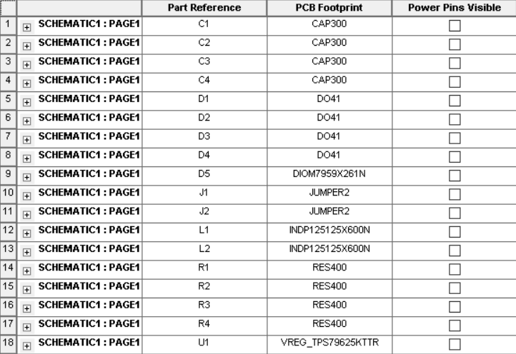

*Figure 5. Component’s Footprints in Cadence Capture design*

Throughout the PCB design process that was learned in class, the team came up with the PCB layout design as shown in Figure 6.

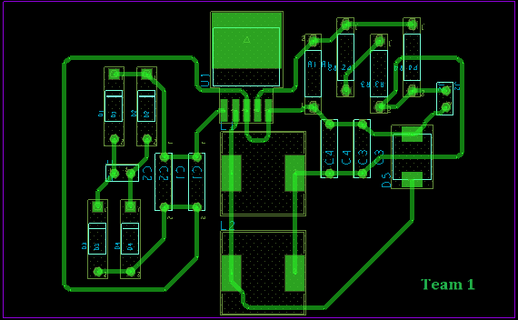

*Figure 6. PCB Layout in Cadence PCB Editor design*

**PCB Manufacturing and Soldering Process**

Once the PCB layout was completed, through the Gerber files and Drill files which were generated from the design, the team started to put the parts onto the PCB. The process of PCB soldering was strictly followed the 4 key regulations [7]:

1. Before soldering, stick to the rules: AVOID (check the schematic and the pins carefully), DENY (if there is anything wrong, stop right at the step) and DEFENSE (use the sucker and start the desoldering process).
2. Soldering order should start from the smallest components first and gradually increase the size of components. This order is to avoid the big component making the PCB board unsteady and become dangerous when soldering.
3. Look at the solder joints to detect for bad solder joints that could lead to short circuit or other mistakes such as soldering bridging, excessive solder, solder balling, cold joint, overheated joint, tombstoning, insufficient wetting, solder skips, lifted pads, solder starved, solder splashes/webbing and pin/plow holes.
4. After turning on the soldering iron and waiting for it to heat up, touch the tip of the iron to the copper pad and the lead soldering thread, hold it in place for a few seconds until the pad and the lead is properly heated.

The team finished soldering the PCB as the figures, from Figure 7 to Figure 14, are showing the different sides of the completed PCB.

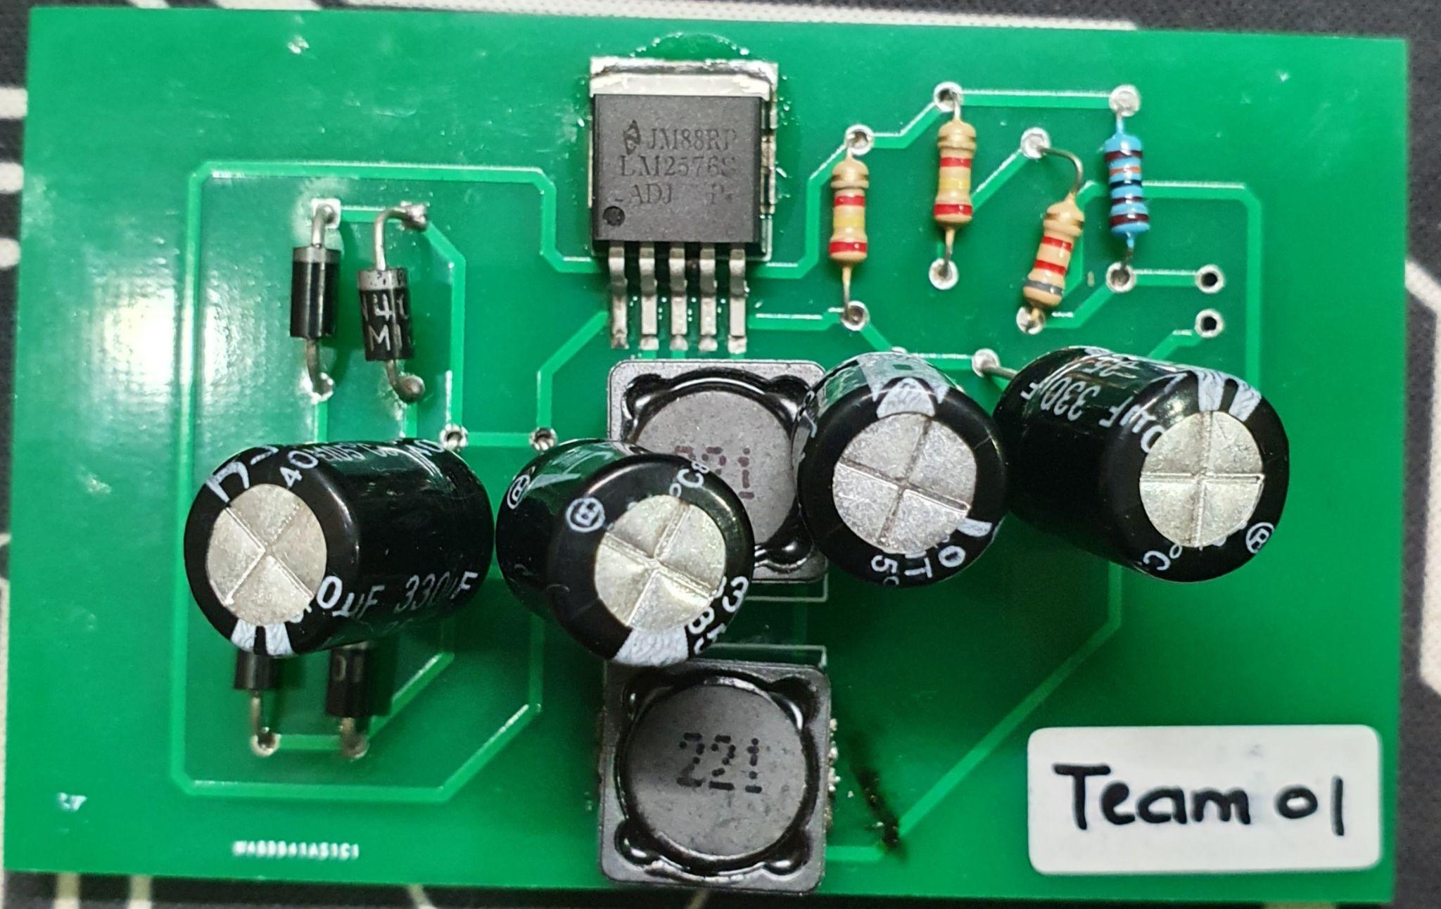

Figure 7. Completed PCB looking from the TOP view 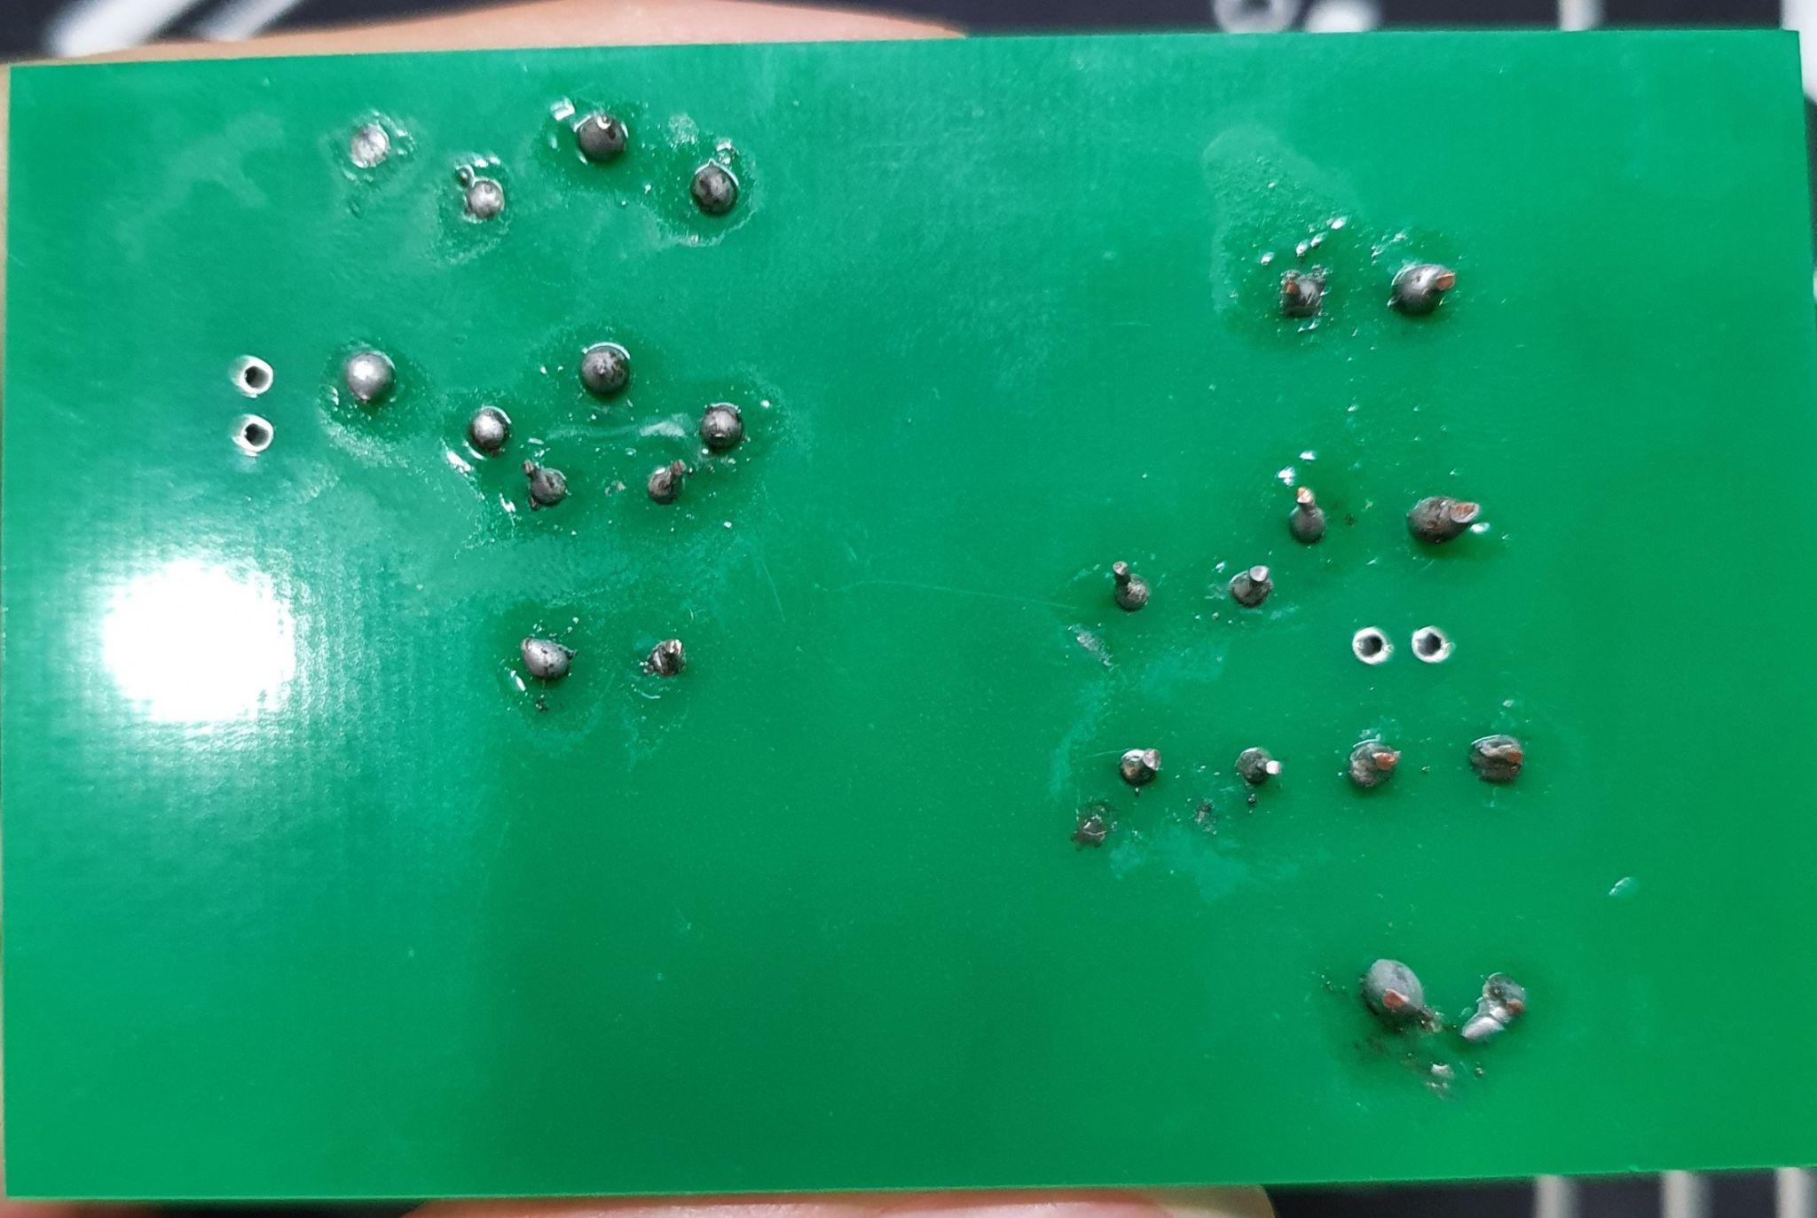

Figure 8. Completed PCB looking from the BOTTOM view

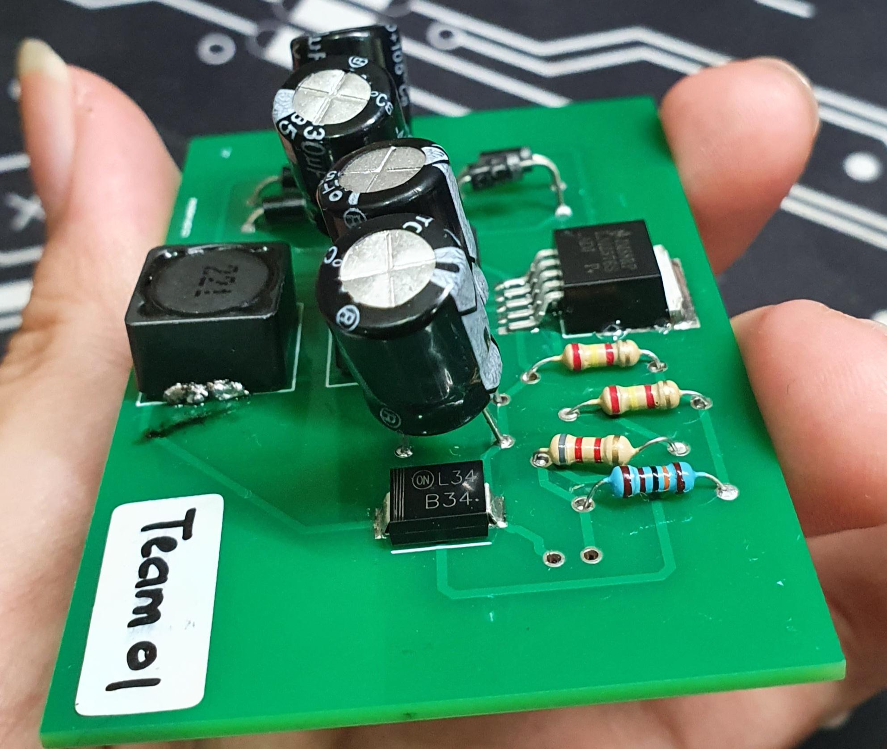

*Figure 9. Completed PCB looking from right to left of the TOP view*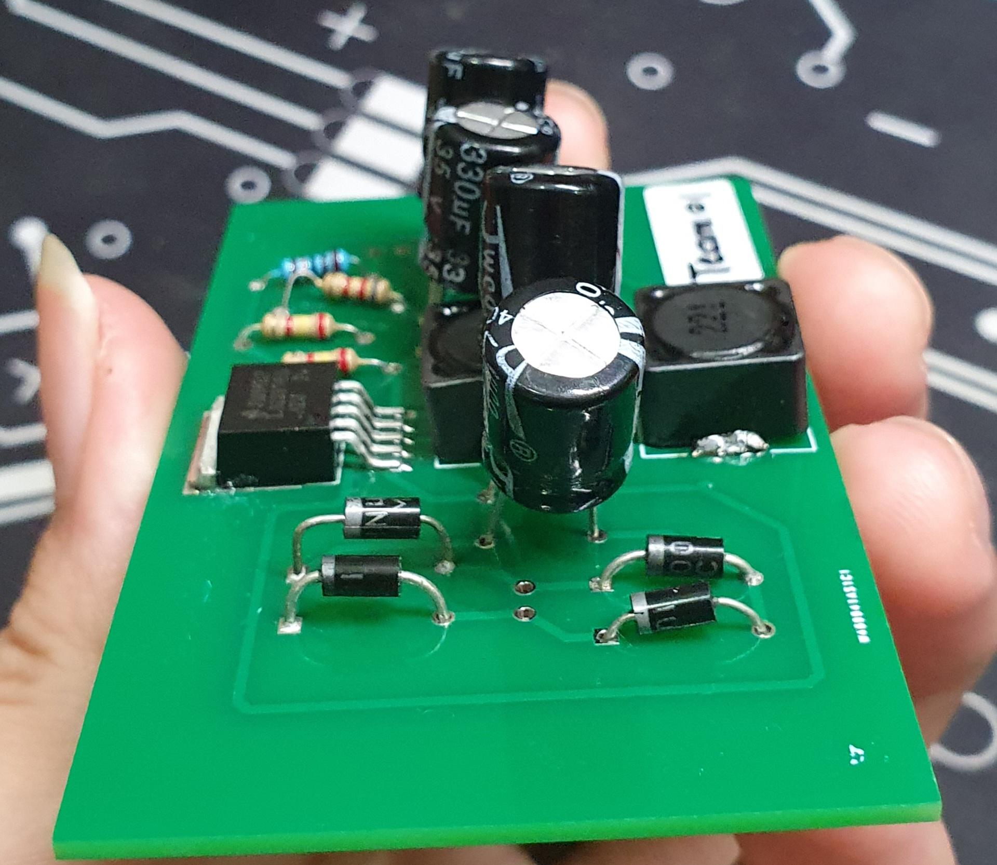

*Figure 10. Completed PCB looking from left to right of the TOP view*

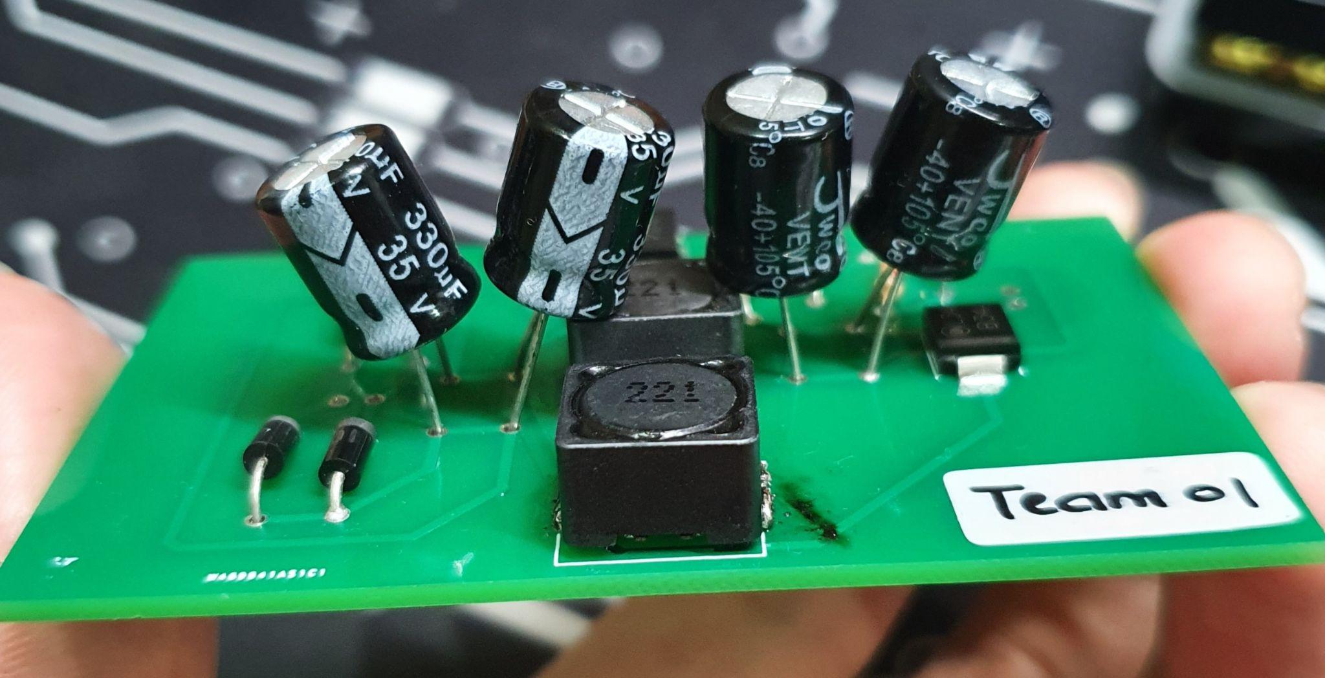

*Figure 11. Completed PCB looking from downside to upside of the TOP view*

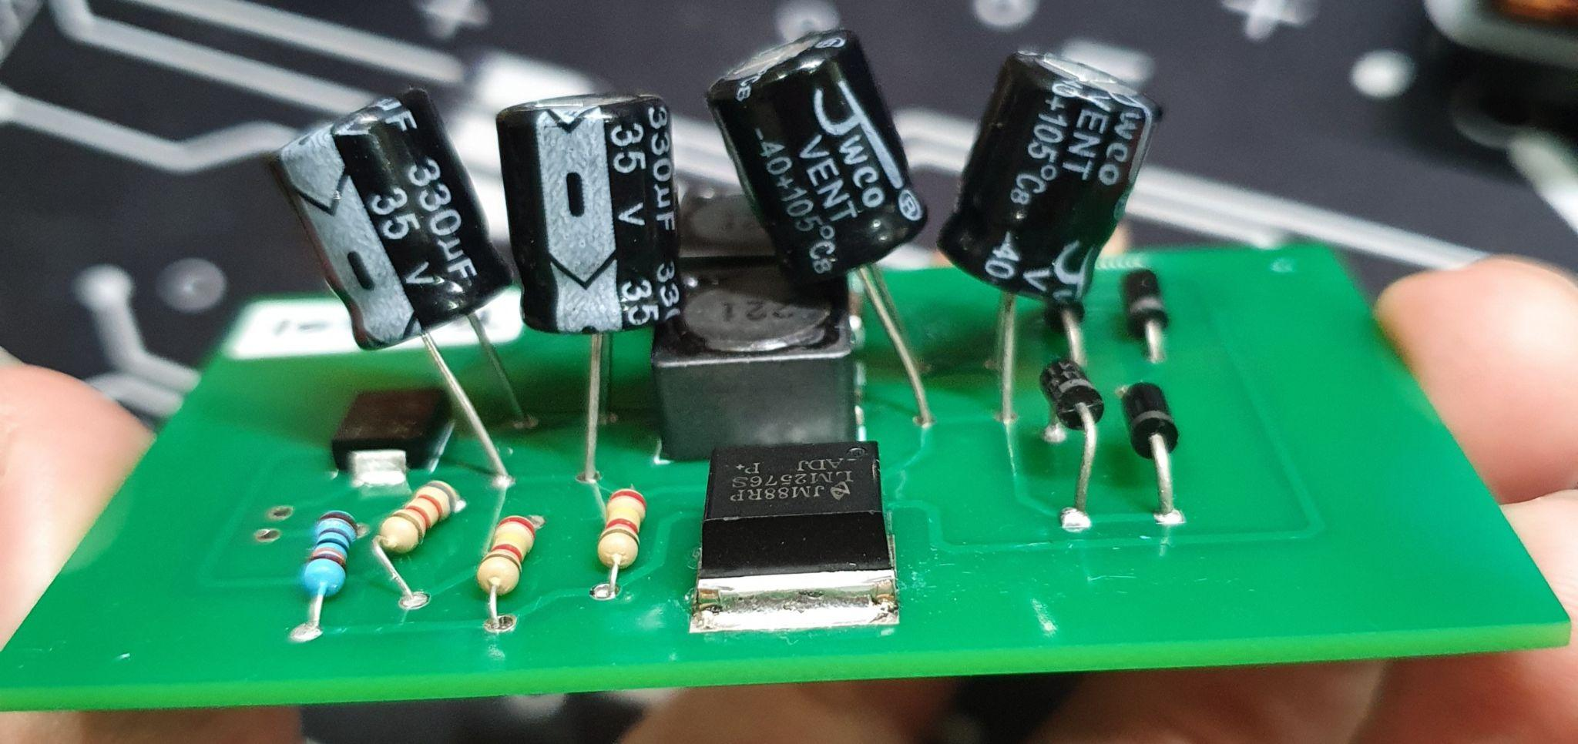

*Figure 12. Completed PCB looking from upside to downside of the TOP view*

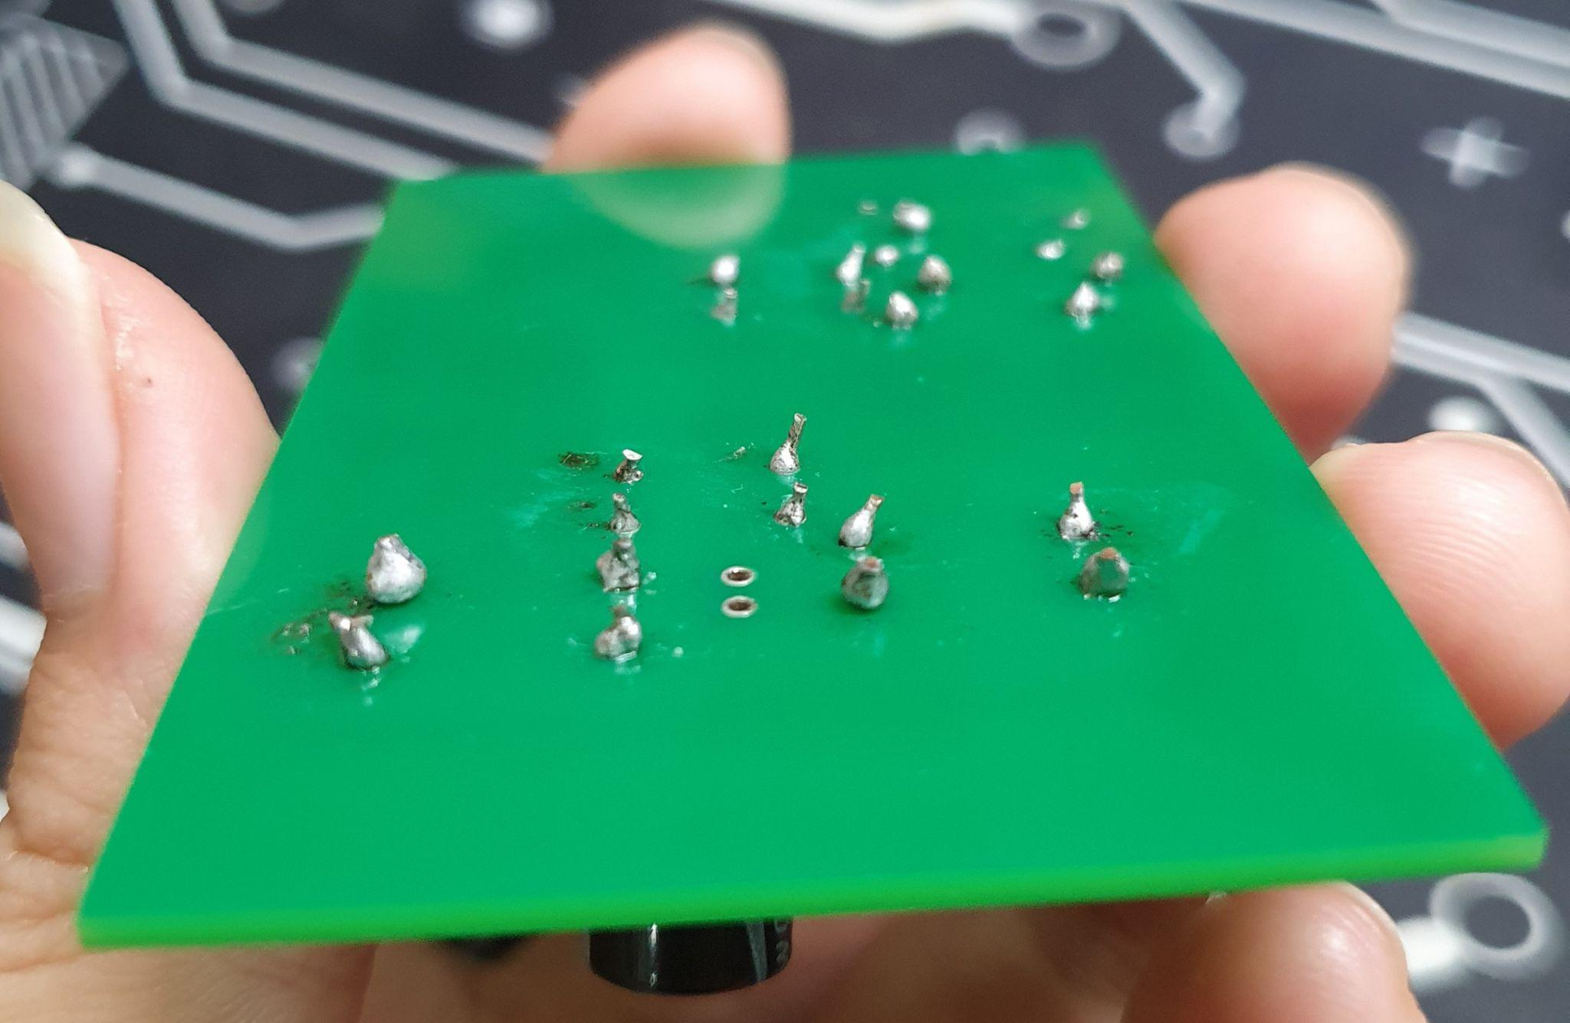

*Figure 13. Completed PCB looking from right to left of the BOTTOM view*

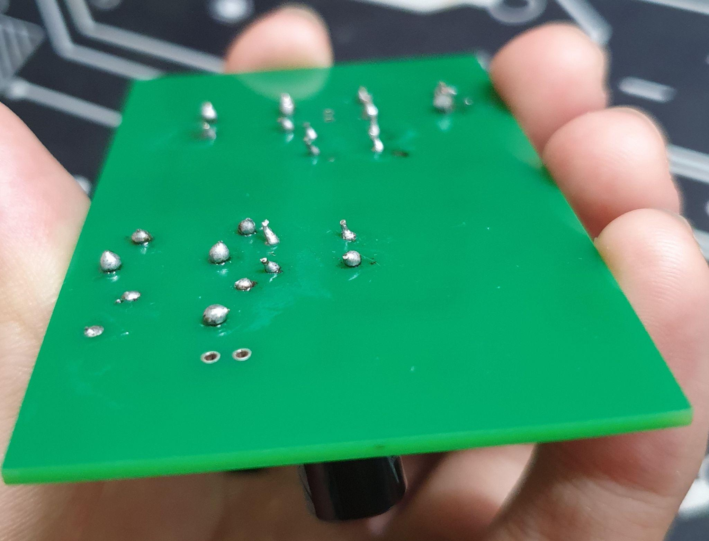

*Figure 14. Completed PCB looking from left to right of the BOTTOM view*

**Circuit Test**

**General Information**

After the PCB was completed, the circuit was tested by NI Elvis Board by using FGEN. The load for testing is measured at approximately 328.26 Ohm resistor. The circuit was set up based on the schematic shown in Figure 1. The setup of the circuit test is shown in Figure 15.

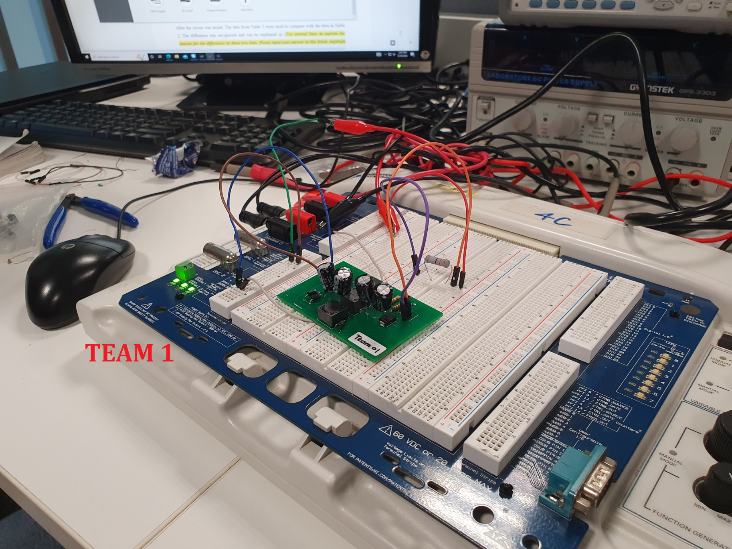

*Figure 15. Actual circuit test setup*

**Circuit Test Data Collection**

The actual tested results are shown in Figure 16.

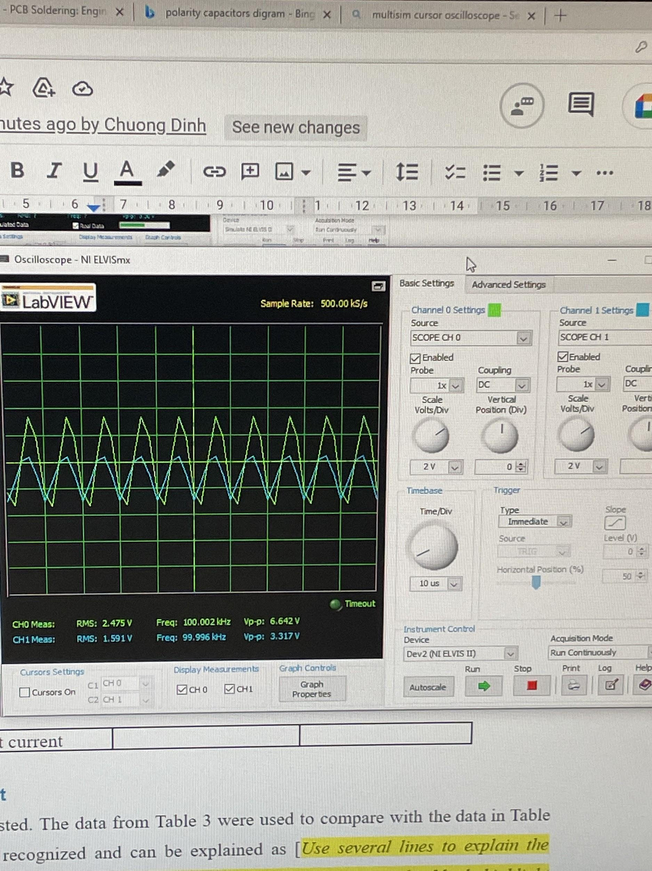

*Figure 16. Actual measured waveform*

Data from the actual experiment was recorded into Table 3.

*Table 3. Actual Measured Data Summary*

|  |  |  |
| --- | --- | --- |
| Data name | Value | Unit |
| Output voltage | 3.317 | V |
| Ripple voltage | 0.049 | V |
| Output current | 0.01 | A |

Output Current = $\frac{Output Voltage}{Load}=\frac{3.317}{328.26}$ = 0.01A

We do the same process to find the Ripple voltage as the NI simulation.

**Discussion of Result**

After the circuit was tested, the data from Table 3 were used to compare with the data in Table 2. The difference was recognized and can be explained as the jumper wires are not soldered to the PCB which creates a good contact with the circuit that can create some noises*.* There are also some tolerances at the soldering joints at each component and the components themselves. All of these can affect the recorded data.

Moreover, compared to what the team designed in Assessment 2, the similarity between the circuits can be listed out as: both circuits are designed to give 3.3V output voltage and are linear regulator ICs.

While there are several differences between them, such as: types of voltage regulator IC used in the circuit and their schematics. In the schematic of Assignment 2 circuit, the Load is connected directly to the IC while in this Assignment, the IC is connected to a Schottky Diode, 2 Inductors, 2 Capacitors, 4 feedback Resistors and then to the Load.

Those differences can be explained as: the application of the new IC in the circuit to increase the power efficiency of the design since it reduces the power loss of the circuit compared to the one used in Assignment 2. In this assignment, C3 and C4 also help to stabilize the output voltage.

**References**

[1] "LM2592HV SIMPLE SWITCHER® Power Converter 150-kHz 2-A Step-Down Voltage Regulator", *TI*, 2022. [Online]. Available: https://www.ti.com/lit/ds/symlink/lm2592hv.pdf?HQS=dis-dk-null-digikeymode-dsf-pf-null-wwe&ts=1663596240965&ref_url=https%253A%252F%252Fwww.ti.com%252Fgeneral%252Fdocs%252Fsuppproductinfo.tsp%253FdistId%253D10%2526gotoUrl%253Dhttps%253A%252F%252Fwww.ti.com%252Flit%252Fgpn%252Flm2592hv. [Accessed: 19- Sep- 2022].

[2] https://www.analog.com/en/technical-articles/output-voltage-noise-measurements-for-linear-regulators.html

[3] "How is line loss calculated?", *ProdataKey*, 2022. [Online]. Available: https://prodatakey.zendesk.com/hc/en-us/articles/360048267913-How-is-line-loss-calculated-. [Accessed: 19- Sep- 2022].

[4] "Series and Parallel Inductors", *ALLABOUTCIRCUITS*, 2022. [Online]. Available: https://www.allaboutcircuits.com/textbook/direct-current/chpt-15/series-and-parallel-inductors/. [Accessed: 19- Sep- 2022].

[5] "What Is a Linear Regulator (LDO Regulator)? Part 2", *Nisshinbo Micro Devices Inc.*, 2022. [Online]. Available: https://www.nisshinbo-microdevices.co.jp/en/design-support/basic/03-linear-regulator.html. [Accessed: 19- Sep- 2022].

[6] "Schottky Diodes: Principle, Functions, and Applications", *Utmel ELECTRONIC*, 2022. [Online]. Available: https://www.utmel.com/blog/categories/diodes/schottky-diodes-principle-functions-and-applications. [Accessed: 19- Sep- 2022].

[7] "EEET2602 - Assessment 4 - Report Template", Rmit.instructure.com, 2022. [Online]. Available: https://rmit.instructure.com/courses/104898/files/26908580?wrap=1. [Accessed: 20- Sep- 2022].